Creation of .s File for a C file

Command- riscv32-unknown-elf-gcc -march=rv32imac -mabi=ilp32 -S hello.c -o hello.s

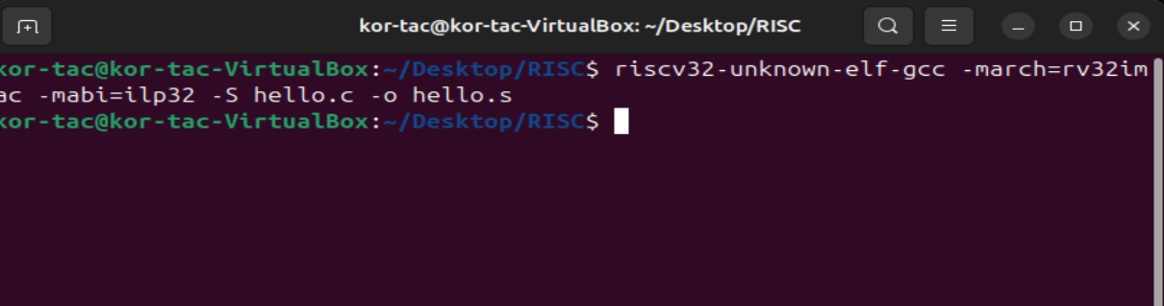

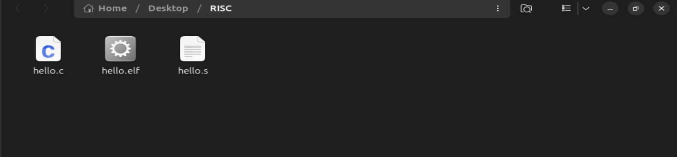

Open the hello.s file

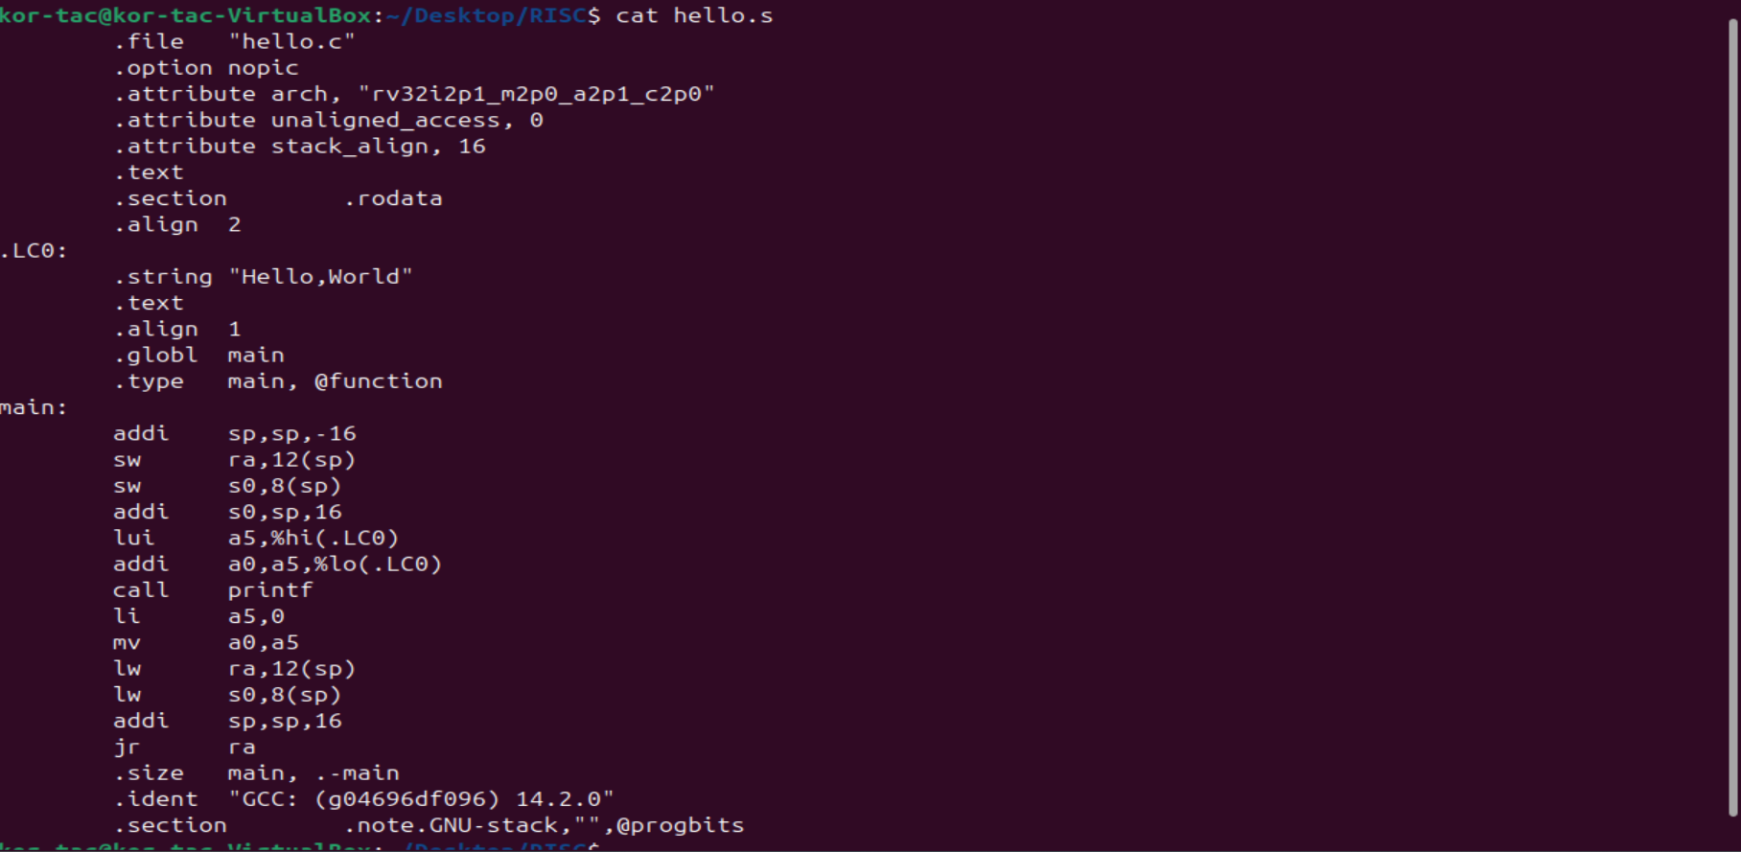

Explanation:

addi sp, sp, -16 # Allocate 16 bytes on stack

sw ra, 12(sp) # Save return address

sw s0, 8(sp) # Save s0 (callee-saved register)

addi s0, sp, 16 # Set s0 as frame pointer

lw ra, 12(sp) # Restore return address

lw s0, 8(sp) # Restore saved frame pointer

addi sp, sp, 16 # Deallocate stack space

ret # Return to caller